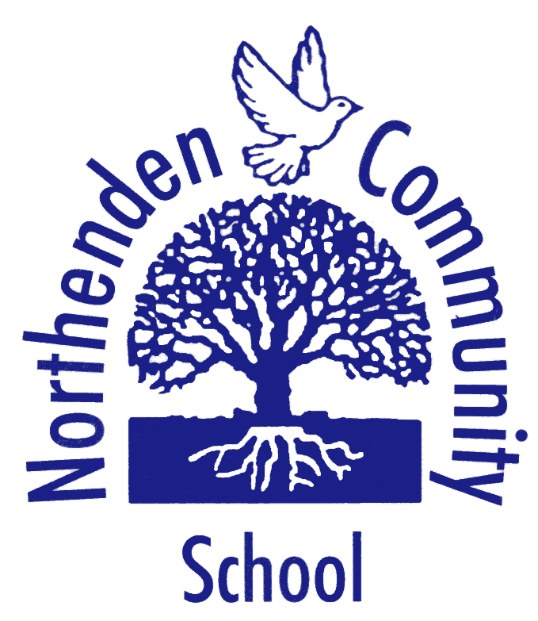 | Northenden Community School  Curriculum Information for Parents | 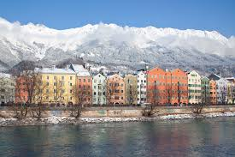
Class | Year 5 (Miss Williams)
Term | Autumn 1 2025 (8 weeks)
Theme | What is life like in the Alps? (Geography)

THE BIG IDEA | In this unit of work, we will use a variety of data collection methods including completing a questionnaire, mapping their route and recording their findings in sketches or photographs. We will also be conducting field work in our own area, to be able to compare human and physical features between Northenden and Innsbruck.

 | In READING lessons, the children will …  - Develop reading and understanding through retrieval, inference and explanation.  - Read a range of genres.  - Retrieve and record information.
 | In WRITING lessons, the children will …  - Write narrative settings.  - Write in persuasive style.  - Summarise longer passages.
 | In MATHEMATICS lessons, the children will…  - Revise place value.  - Addition and subtraction.  - Multiplication and division.
 | In COMPUTING lessons, the children will  - Learn about computing systems and networks: search engines.  - Online safety.

  In SCIENCE we will …  - Investigate living things and their habitats.  - Define habitats.  - Explain what natural environments are.  - Explore how different environments suit different organisms.    In GEOGRAPHY we will …  - Locate the Alps.  - Locate the physical and human characteristics of the Alps.  - Describe the physical and human features of an Alpine region.  - Investigate and data collect in our local area.  - Compare our local area and an Alpine area.    - Understand the human and physical geography of the Alps.  In Religious Education we will learn…  - What do people think about God?  - Why do people stand up for what they believe in? |  | In ART AND DESIGN we will …  - Create sketch books to record observations and use them to revisit ideas.  - Improve their mastery of drawing, charcoal and pencil.  - Study great artists from history.  In MUSIC we will …  - Learn about traditional instruments and improvisation.  - Play a trumpet/trombone.  - Perform, listen, review and evaluate music.  - Compose their own music.  In PSHCE we will …  - Learn and understand that stereotypes exist and that these can lead to discrimination.  - Think about the qualities of a good friend.

 | PE lessons will take place on THURSDAYS  In our PE lessons, the children will …  - Use running, jumping, throwing and catching in isolation and combination.  - Play competitive games.  - Basic principles of attacking and defending.
 | OTHER INFORMATION  - Homework will be set every Friday  - The children have a weekly spelling test on Fridays.
 | YOU CAN HELP YOUR CHILD AT HOME BY …  - Reviewing their report from last year and encouraging them with their targets  - Reading with them and sharing in their learning on a regularly (daily) basis;  - Ensuring that homework is completed on time and to the best of their ability.

